Greater Houston Land Cover Change Dataset: 1997-2017
Technical Report

Description
Land cover data for the 13-county Houston-Galveston Area Council (HGAC) at 30m spatial resolution, annual temporal resolution, 21-year temporal extent, and nine class thematic resolution. Classifications are derived from 30m Landsat 5 Thematic Mapper (TM), Landsat 7 Enhanced Thematic Mapper (ETM+), and Landsat 8 Operational Land Imager (OLI) imagery. Training classes are based on NLCD land cover data from 2001 (Homer et al. 2007), 2006 (Fry et al. 2011), and 2011 (Homer et al. 2015). The classification is based on Automated Adaptive Signature Generalization (AASG) (Dannenberg et al. 2016), random forests classification, and spatio-temporal filtering algorithms (Hakkenberg et al. 2018a, Hakkenberg et al. 2018b). All classifications are validated with independent accuracy assessments and inter-classification comparisons (Hakkenberg et al. 2018a).

References used in the above description
Dannenberg, M.P., Hakkenberg, C.R., & Song, C. 2016. Consistent classification of Landsat time series with an improved automatic adaptive signature generalization algorithm. Remote Sensing 8(8), 691.

Fry, J. a., Xian, G., Jin, S., Dewitz, J. a., Homer, C.G., Yang, L., Barnes, C. a., Herold, N.D., & Wickham, J.D. 2011. Completion of the 2006 National Land Cover Database for the conterminous United States. Photogrammetric Engineering and Remote Sensing 77: 858–566.

Hakkenberg, C.R, Dannenberg, M.P., Song, C., and K. Ensor (2018a, in review). Automated, multi-decadal land-cover classification of the greater Houston area using signature generation of a Landsat time series.

Hakkenberg, C.R. and K. Ensor (2018b, in review). Space-time Remote Sensing Reconstruction of changing Landcover for Houston.

Homer, C., Dewitz, J., Fry, J., Coan, M., Hossain, N., Larson, C., Herold, N., Mckerrow, A., Vandriel, J.N., & Wickham, J. 2007. Completion of the 2001 National Land Cover Database for the Conterminous United States. Photogrammetric Engineering & Remote Sensing 73: 337–341.

Homer, C.G., Dewitz, J.A., Yang, L., Jin, S., Danielson, P., Xian, G., Coulston, J., Herold, N.D., Wickham, J.D., & Megown, K. 2015. Completion of the 2011 National Land Cover Database for the conterminous United States-Representing a decade of land cover change information. Photogrammetric Engineering and Remote Sensing 81: 345–354.

Source
Chris Hakkenberg provided files to the UDP on 2/19/2018. Source data include 21 geoTIFF files (1997.TIFF – 2017.TIFF) and 1 color layer file (Clr_71.lyr). These constitute the Version 2 data.

Chris Hakkenberg provided updated files to the UDP on 9/4/2018. Source data include 21 geoTIFF files (1997.TIFF – 2017.TIFF). Chris Hakkenberg confirmed that the same color layer file (Clr_71.lyr) that was given in Version 2 can be used. These constitute the Version 4 data. This update fixed an issue where <2000 pixels (<0.00002%) in 2007 were erroneously labeled “sand” when they should have been labeled “impervious”.

Suggested Citations and DOIs
When using these datasets, use the suggested APA-styled citations below.

Hakkenberg, C. R. (2018). Greater Houston Land Cover Change Dataset: 1997-2017 (Version 2) [Data set]. Rice University-Kinder Institute: UDP. https://doi.org/10.25612/837.zbn96g5x658z

Hakkenberg, C. R. (2018). Greater Houston Land Cover Change Dataset: 1997-2017 (Version 3) [Data set]. Rice University-Kinder Institute: UDP. https://doi.org/10.25612/837.zky64nnmo9y3

Hakkenberg, C. R. (2018). Greater Houston Land Cover Change Dataset: 1997-2017 (Version 4) [Data set]. Rice University-Kinder Institute: UDP. https://doi.org/10.25612/837.al72581lw7md

Hakkenberg, C. R. (2018). Greater Houston Land Cover Change Dataset: 1997-2017 (Version 5) [Data set]. Rice University-Kinder Institute: UDP. https://doi.org/10.25612/837.5mloxpp803wq

Alternatively, go to https://citation.crosscite.org/ and enter the following digital object identifiers to generate a citation in the style of your choice.

Version | Digital Object Identifier (DOI)
2 | 10.25612/837.zbn96g5x658z
3 | 10.25612/837.zky64nnmo9y3
4 | 10.25612/837.al72581lw7md
5 | 10.25612/837.5mloxpp803wq

Processing

Class Descriptions for v02, v03, v04, and v05
Class code | Class name | NLCD equivalent | Class description
1 | Barren / Sand | 31 | Anthropogenically impacted areas of unconsolidated dirt and rock (e.g. dirt lots, strip mines, gravel pits and other accumulations of earthen material).
2 | Developed – open | 21 | Includes areas with a mixture of some constructed materials, but mostly vegetation in the form of lawn grasses. Impervious surfaces account for less than 20 percent of total cover. These areas most commonly include large-lot single-family housing units, parks, golf courses, and vegetation planted in developed settings for recreation, erosion control, or aesthetic purposes.
4 | Developed – low intensity | 22 | Includes areas with a mixture of constructed materials and vegetation. Impervious surfaces account for 20-49 percent of total cover. These areas most commonly include single-family housing units.
8 | Developed – medium intensity | 23 | Includes areas with a mixture of constructed materials and vegetation. Impervious surfaces account for 50-79 percent of the total cover. These areas most commonly include single-family housing units.
13 | Developed – high intensity | 24 | Includes highly developed areas where people reside or work in high numbers. Examples include apartment complexes, row houses and commercial/industrial. Impervious surfaces account for 80 to 100 percent of the total cover.
21 | Agriculture | 82 | Cultivated Crops – Areas used for the production of annual crops, such as corn, soybeans, vegetables, tobacco, and cotton, and also perennial woody crops such as orchards and vineyards. Crop vegetation accounts for greater than 20 percent of total vegetation. This class also includes all land being actively tilled.
35 | Grassland / Pasture | 71, 81, 95 | grassland/herbaceous/pasture – Upland and wetland areas dominated by grammanoid or herbaceous vegetation. These areas may or may not be subject to intensive management such as tilling, grazing, or the production of seed or hay crops.
50 | Forest | 41, 42, 43, 52, 90 | grassland/herbaceous/pasture – Upland and wetland areas dominated by grammanoid or herbaceous vegetation. These areas may or may not be subject to intensive management such as tilling, grazing, or the production of seed or hay crops.
71 | Water | 11 | All areas of open water.

Geospatial Metadata for v02, v03, v04, and v05

Temporal extent:
1997-2017

Spatial extent:
Houston-Galveston Area Council (H-GAC) 13-county area: Austin, Brazoria, Chambers, Colorado, Fort Bend, Galveston, Harris, Liberty, Matagorda, Montgomery, Walker, Waller, and Wharton counties.

Spatial resolution:
30m (98.40319 ft)

Spatial_Reference_Information:
Projected Coordinate System: NAD_1983_2011_StatePlane_Texas_South_Central_FIPS_4204_FtUS
Projection: Lambert_Conformal_Conic
Linear Unit: Foot_US
Geographic Coordinate System: GCS_NAD_1983_2011
Datum: D_NAD_1983_2011

How v03 and v05 files were created
All 21 TIFF files of v02 and v04 were transformed to ESRI GRID format (v03 and v05, respectively).

The clr_71.lyr layer file has been transformed into a color map file that can be directly applied to the GRID raster. This is to automatically display the colors once a user adds the GRID raster to ArcGIS workspace.

A new field called ‘LULC’ was also added to the raster’s attribute table to label the values with the land use classification.

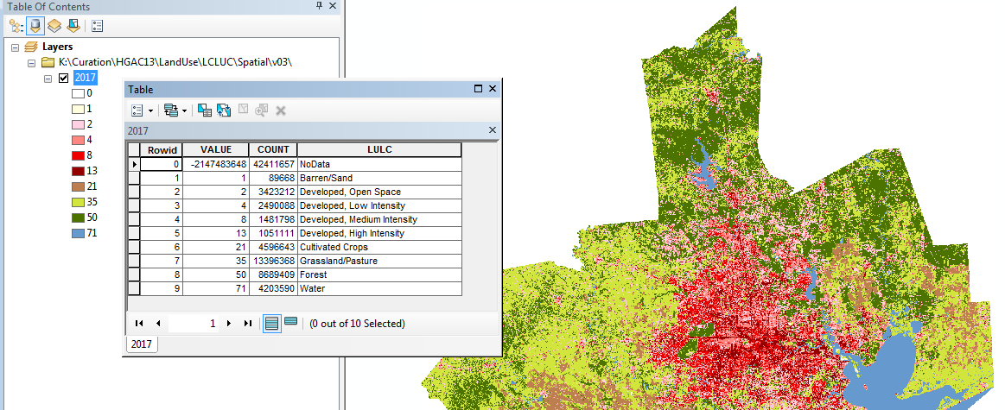
Screenshot of 2017 GRID raster with attribute table

Published File(s), Programs and Audit Trail

The following table details the audit trail for the creation of v03 and v05. Values for yyyy range from 1997 to 2017.
Program Name | Input File(s) | Output File(s) | Date/  Time Run
The  Add_colormap_to_rasters.py  Python script was used to convert the TIFF files to ESRI GRID rasters and apply the classification labels to the attribute table of each raster. | Version 2 files:  yyyy.tif  clr_71.lyr  LULCclrmap.clr | Version 3 files:  yyyy.aux.xml  yyyy.clr  yyyy.ovr  yyyy folders with the following files:  dblbnd.adf  hdr.adf  metadata.xml  prj.adf  sta.adf  vat.adf  w001001.adf  w001001x.adf  An info folder with the following files:  arc.dir  arc0000.dat  arc0000.nit  arc0001.dat  arc0001.nit  …  arc0062.dat  arc0062.nit | 03/01/2018 4:50pm
The  Add_colormap_to_rasters.py  Python script was used to convert the TIFF files to ESRI GRID rasters and apply the classification labels to the attribute table of each raster. | Version 4 files:  yyyy.tif  clr_71.lyr  LULCclrmap.clr | Version 5 files:  yyyy.aux.xml  yyyy.clr  yyyy.ovr  yyyy folders with the following files:  dblbnd.adf  hdr.adf  metadata.xml  prj.adf  sta.adf  vat.adf  w001001.adf  w001001x.adf  An info folder with the following files:  arc.dir  arc0000.dat  arc0000.nit  arc0001.dat  arc0001.nit  …  arc0062.dat  arc0062.nit | 10/16/2018 ‏‎10:34 AM

