Board Characteristics - A Confirmatory Factor Analysis

Latent Variables: inequality communication trust control turnover

Relationships:
LOCAL18 - LOCAL20 = inequality
LINK5 - LINK8 = communication
LINK10 - LINK12 = trust
LINK13 - LINK16 = control
ATTITU11 - ATTITU14 = turnover

!Print Residuals
Path Diagram

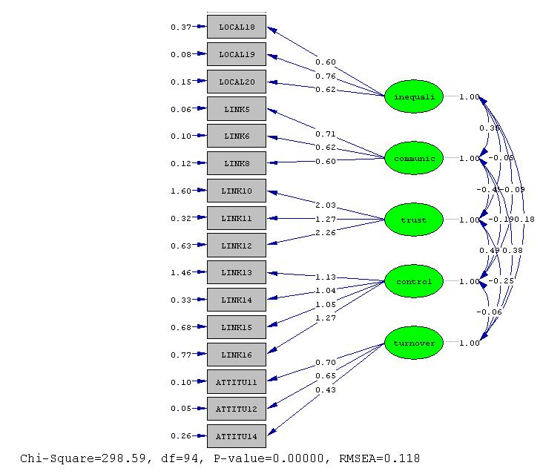

Model has way too high Chi-square, its p-value is zero, indicating mis-specified.

Goodness of Fit Statistics

Degrees of Freedom = 94
H Minimum Fit Function Chi-Square = 330.9830 (P = 0.0)
L Normal Theory Weighted Least Squares Chi-Square = 298.5868 (P = 0.0)
H Estimated Non-centrality Parameter (NCP) = 204.5868
90 Percent Confidence Interval for NCP = (156.1666 ; 260.6230)

Minimum Fit Function Value = 2.1082
Population Discrepancy Function Value (F0) = 1.3031
90 Percent Confidence Interval for F0 = (0.9947 ; 1.6600)
H (.05) Root Mean Square Error of Approximation (RMSEA) = 0.1177
H (.05-.08) 90 Percent Confidence Interval for RMSEA = (0.1029 ; 0.1329)
L P-Value for Test of Close Fit (RMSEA < 0.05) = 0.0000

H Expected Cross-Validation Index (ECVI) = 2.4369
90 Percent Confidence Interval for ECVI = (2.1284 ; 2.7938)
(ECVI < ECVI_sat) ECVI for Saturated Model = 1.7325
ECVI for Independence Model = 15.8877

Chi-Square for Independence Model with 120 Degrees of Freedom = 2462.3639
Independence AIC = 2494.3639
Model AIC = 382.5868
Saturated AIC = 272.0000
Independence CAIC = 2559.3654
Model CAIC = 553.2158
Saturated CAIC = 824.5129

H Normed Fit Index (NFI) = 0.8656
H Non-Normed Fit Index (NNFI) = 0.8708
H Parsimony Normed Fit Index (PNFI) = 0.6780
H Comparative Fit Index (CFI) = 0.8988
H Incremental Fit Index (IFI) = 0.8999
H Relative Fit Index (RFI) = 0.8284

Critical N (CN) = 62.0982

Root Mean Square Residual (RMR) = 0.07969
Standardized RMR = 0.07162
Goodness of Fit Index (GFI) = 0.8079
Adjusted Goodness of Fit Index (AGFI) = 0.7221
Parsimony Goodness of Fit Index (PGFI) = 0.5584

The Modification Indices Suggest to Add the
Path to from Decrease in Chi-Square New Estimate
LOCAL18 communic 11.7 0.19
LOCAL18 turnover 11.3 0.18
LOCAL19 communic 12.0 -0.16
LOCAL19 turnover 8.1 -0.12
ATTITU12 inequali 10.7 -0.10
ATTITU14 inequali 8.7 0.13

I made these recommended changes:

The new model decreased the Chi Square score to from 298 to 268, (still p-val zero), but it did not make enough change in any other the other tests. In another sample problem, implementing the system recommendations changed the chi-sq/p-val scores from (53, .000648) [reject model], to (15.5, .80) [accept], so the system does know what it is talking about. In our case it did not make enough difference.

Relationships:
LOCAL18-LOCAL20 ATTITU12-ATTITU14 = inequality
LINK5 - LINK8 LOCAL18 LOCAL19 = communication
LINK10 - LINK12 = trust
LINK13 - LINK16 = control
ATTITU11-ATTITU14 LOCAL18 LOCAL19 = turnover

With corresponding “messier” path diagram

Will try some exploratory factor analysis.

-John

