Introduction to Statistical Computing in Microsoft Excel for Stat 280
By Hector D. Flores; hflores@rice.edu

Statistics lab will be mainly focused on applying what you have learned in class with real (or simulated) data. As applied statisticians, we are commonly interested in 3 things: accessing data, analyzing it, and forming reasonable conclusions. Computer software packages, such as Excel, help us with the first and second items. The following brief tutorial will show you some fundamental tools that you will need in this course.

Importing/Accessing Data

Unless you enjoy the painful process of number crunching by hand, it’s a good idea to get your data into a computer with programs to make these calculations easier.

Common problem: Most often data does not come in a format that is readily accessible to you. Since we are using Excel, the best-case scenario will be if the data is in Excel format already. However, for the sake of education, suppose we have the “next-best-case” scenario of the data in delimited text file format. An example of this is the following (see excel_sample.txt on the web page):

Count Time Brake
1 1.6 1.9
2 2.3 2.9
3 9.5 1.110
4 1.2 2.34

This is the case where the text file is “tab-delimited”. That is, “tab” spacing separates the data. There are other forms of delimiters: commas, semicolons, asterisks, etc. Typically, most reasonable people will separate their data in a logical fashion (and you should expect data like this in this course).

So what do you do if the data you get in real life is not one of these scenarios? Well, there are ways to deal with it, but that’s beyond the scope of this tutorial. Ask me if you really want to know, or have a problem.

Now, assuming your data is “delimited” in some way, Excel loves you. You can import the data using the following steps (Try this with excel_sample.txt):

Import Step 1 – Go to File → Open
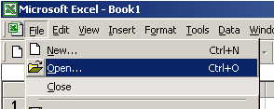

Import Step 2 – Find your file, and click Open. Note: You may have to change Files of type to All Files to see your file.

Import Step 3 – The import wizard will appear on the screen.
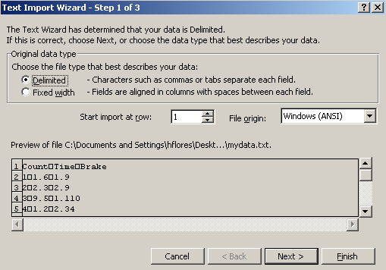

Honestly, you can mess around with the settings here till you get the desired result in the Preview window. Since I know my file is delimited, I make sure it is selected and click Next.

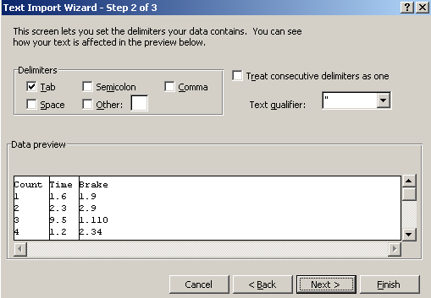

You should see the columns line up correctly (see above picture) in the Data preview. Clicking on Next or Finish here will import the data.

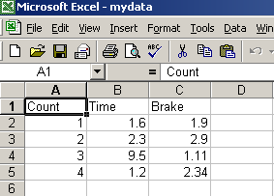
Yeah.
Data Analysis

Now that you have data in Excel, what do we do with it?

Answer: Compute statistics with relative ease.

First some notes about Excel. Each cell can hold an object: a character string, a number, an equations, picture, etc. We will mostly be concerned with equations. To enter an equation in any empty cell, first type “=” and then type the desired expression.

Example: To add cells A2 and A3, click on an open cell (where you want the result to be) and enter “= A2 + A3” (and hit the enter key or click away from the cell). The result should be there. Failure to type the “=” will result in the text “A2 + A3”. Try making other equations yourself.

Trick #1: Suppose we wanted to add cell 2 and cell 3 from each column (not just A as in the above example). Assuming that you’ve tried the above example, click on the cell with the “=A2+A3” equation in it. Copy this equation (CTRL+C) and paste the equation (CTRL+V) in the next cell to the right. Now look at the equation in the equation bar. It should read “=B2+B3”. Experiment with this idea, moving to other cells.

Trick #2: Suppose you want to add all the numbers in a particular column, but don’t want to burden yourself with typing all the cell identifiers. Click on the cell you want to put the formula and type “= SUM(”. Then, move your mouse to the first element, click-and-drag to the last element you wish to add, and type <enter>. Experiment with this “click-and-drag” technique with other formulas.

Trick #3: Suppose that you want to move formulas back and forth as in Trick 1, but you don’t want one of the values to move. For example, suppose you want to copy the formula over, and keep the formula saying “=A2+A3” (instead of the default, which changes the letters and numbers). Simply place “$” in front of those letters that you want to remain constant (e.g. “=A2+A3” can becomes “=$A$2+$A$3” to hold the entire equation constant). Experiment with this to get the hang of it.

So where are the statistics?

Well, hopefully by now you’ve learned how to compute such statistics as the mean, median, mode, range, IQR, etc. You can physically enter these formulas into particular cells manually…or…you can cheat and use the built-in functions provided by Excel.

To access these functions, go to Insert → Function
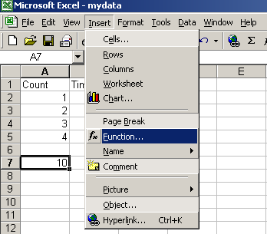

Then in the Function Category, select Statistical. You can then choose from any of the functions in the Function name category.
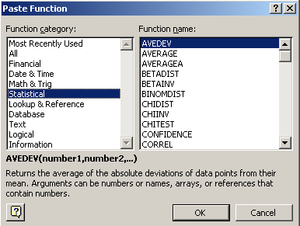

Examples:

AVERAGE(A1,A2)
AVERAGE(A1:A10) [average rows 1-10 in column A]
MAX(A2:A5,B2:B5,C2:C5) [gives the largest number of all these cells]
MIN(A2:A5,B2:B5,C2:C5) [the smallest]
MEDIAN(A1:A9) [the median]
MODE(B1:B100) [the mode]
STDEV(B1:B100) [standard deviation]

