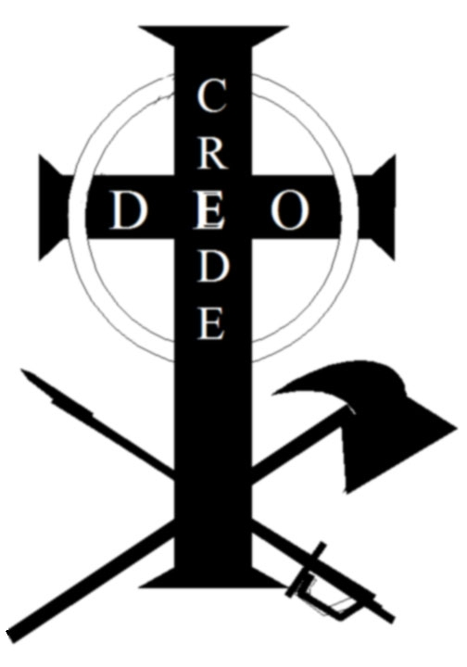
Share our vision. You’ve seen the Crede Deo logo Jake made. Send Janet an email and join the Crede Deo for $5 donation. You will receive a decal in the mail.

Here’s one man’s opinion of what the crede means to him.

When I first saw the Crede Deo logo, I assumed it was in response to 9/11, since it was on all of our minds then. I saw the axe and thought of the firefighters who were running towards the danger in NYC and Washington DC. I also thought of the police who put themselves out there everyday so it can be safer for the general public, also known as people like me. Then, I saw the sword and thought of the soldiers who were going off to fight against "enemies of our country". Then, I thought of the cross and the wording to mean trusting in god, but someone has to pick up the tools and make things happen sometimes.

It was much later when I realized that Jacob had created this to represent himself, and not the legions of service people who protect us around the world. But, it represents the best of what a person can ask for in a citizen as someone who serves, especially voluntarily, to maintain the peace and comfort of those around him.

When I look at it, I remember this about Jacob, but not only Jacob. I remember that on a daily basis there are fires to fight, criminals to catch, and enemies to defend against. The people who are working to make the world a safer place are all represented by the "Crede Deo" logo and what it stands for. This is what Jacob stood for, and that is what makes it so cool. But, it also reminds me of Bucky Kallies, a career firefighter in HFD. I also think about Taylor Williams, a member of US Special Forces serving in Iraq. I also think about the millions I don't know personally, but are working in my interest right now.

David Cook.

